PENNSYLVANIA
PUBLIC UTILITY COMMISSION
Harrisburg, PA 17105-3265

Public Meeting held May 6, 2010

Commissioners Present:

James H. Cawley, Chairman
Tyrone J. Christy, Vice Chairman, Dissenting in Part
Wayne E. Gardner
Robert F. Powelson

Pennsylvania Public Utility Commission  v.  The Peoples Natural Gas Company, d/b/a,  Dominion Peoples |  | M-2009-2086651

Opinion and Order

BY THE COMMISSION:

Before the Commission for consideration and disposition is a Settlement Agreement (Settlement or Settlement Agreement) originally filed on January 23, 2009, by The Peoples Natural Gas Company, d/b/a Dominion Peoples (Dominion Peoples or the Company) and the Commission’s Law Bureau Prosecutory Staff (Prosecutory Staff) collectively, “the Parties,” with respect to an Informal Investigation conducted by the Prosecutory Staff. Also before the Commission are the Comments submitted by the Public Utility Law Project (PULP) and the Office of Consumer Advocate (OCA) with respect to the revised Settlement Agreement. The Parties submit that the proposed Settlement Agreement is in the public interest and complies with the Commission’s Policy Statement at 52 Pa. Code § 69.1201 (Factors and standards for evaluating litigated and settled proceedings involving violations of the Public Utility Code and Commission regulations—statement of policy). Settlement at 8, 11; ¶¶ 33, 44. Further, the proposed Settlement is submitted as contingent on Commission approval without any waivers, or other approvals to effectuate its terms. Settlement at 13; ¶ 51. If the Commission does not approve the Settlement without modification, either party may elect to withdraw from the Settlement. Settlement at 14; ¶ 52.

History of the Case

The Settlement Agreement has been brought before the Commission by the Parties in order to resolve allegations of multiple violations of the Code of Federal Regulations and the rules and regulations of the Commission relative to natural gas pipeline safety. The specific incidents that are the subject of the Settlement Agreement occurred on May 2, 2007, June 8, 2007, and June 21, 2007.

On May 2, 2007, a contractor using a backhoe damaged a service line connected to a dwelling in Tyrone, Pennsylvania. Settlement at ¶¶ 12-13. A Commission Gas Safety Division Inspector subsequently found that Dominion had failed to follow proper procedure in abandoning the line. Settlement at 4; ¶¶ 14-15. If proven, this conduct would be in violation of 49 C.F.R. § 192.605(a), (b)(8) – Procedural Manual for Operations, Maintenance, and Emergencies; 49 CFR § 192.13(c) - General; 49 CFR 192.603 – General Provisions; 52 Pa. Code § 59.33(a) – Safety; and 52 Pa Code
§ 59.36(5) – Abandonment of Inactive Service Lines.

On June 8, 2007, a contractor damaged a pipeline in West Mifflin, Pennsylvania. A Commission Gas Safety Division Inspector subsequently discovered after a review of Dominion’s records that Dominion personnel did not accurately mark the
eight inch steel gas main in the proposed area of excavation and that the Dominion contract locator did not locate the pipeline because he misinterpreted the actual location of the pipeline on the map. Settlement at 5; ¶¶ 22-23. If proven, this conduct would be a violation of 49 C.F.R. § 192.614- Damage and Prevention Program and 52 Pa. Code
§ 59.33 (a) – Safety.

On June 21, 2007, a Commission Gas Safety Inspector inspected Dominion’s records related to valve maintenance at the Wilkinsburg, Altoona, and Kiski facilities located throughout Western Pennsylvania and found that three Dominion employees utilized for valve maintenance were not qualified and five employees had expired qualifications related to Federal and State Operator qualifications rules. Settlement at 5; ¶¶ 24-25. If proven, this conduct would constitute violations for each employee for every day that each was so employed, but not qualified of 49 C.F.R. § 192.805 – Qualification Program.

An Informal Investigation was conducted pursuant to Subsection 331(a) of the Public Utility Code, 66 Pa. C.S. § 331(a), and Section 3.113 of the Commission’s Rules of Practice and Procedure, 52 Pa. Code § 3.113.

After the Informal Investigation, and in accordance with 52 Pa. Code § 3.113(b)(3), Prosecutory Staff and Dominion Peoples entered into discussions regarding settling this matter without the need for an on-the-record proceeding. Those discussions resulted in a proposed Settlement. Prosecutory Staff and Dominion Peoples jointly support the proposed Settlement. The Parties aver that the proposed Settlement is in the public interest and request that the Commission approve the Settlement.

Note, however, that at our Public Meeting of May 14, 2009, we adopted the Motion of Vice Chairman Tyrone J. Christy which recommended, subject to comment from interested parties, that Paragraph 31 A of the proposed Settlement be amended to reflect the manner in which Dominion Peoples manages its LIURP program. The proposed amendatory language to Paragraph 31 A of the Settlement reads:

To pay, in lieu of a civil penalty pursuant to 66 Pa. C.S. § 3301(c), five thousand dollars ($5,000) as an increment to the Commission-Approved 2009 LIURP budget of $610,000 establishing a revised 2009 LIURP budget of $615,000. The incremental $5,000 shall be administered by the outside contractor consistent with the current practice. The Company shall not claim or include any portion of this civil penalty amount in any future rate proceeding.

In addition to issuing the proposed Settlement as submitted for comment by interested parties, we directed that all interested parties be afforded an opportunity to comment with respect to whether Paragraph 31 A of the proposed Settlement should be revised in this fashion.

On May 28, 2009, subsequent to the Public Meeting of May 14, 2009, but before the entry of this Order, the Law Bureau and Dominion Peoples filed a joint letter with the Secretary of the Commission agreeing to amend the proposed Settlement to include the recommended amendment to Paragraph 31 A, above.

On September 30, 2009, PULP filed Comments in this proceeding supporting the Settlement Agreement, generally, and the revised language of Paragraph 31 A, specifically.

On September 30, 2009, the OCA filed Comments in this proceeding supporting the Settlement Agreement, generally, and the revised language of Paragraph 31 A, specifically, but recommended the addition of a reporting requirement and clarification that Dominion Peoples not be allowed to seek rate recovery of the $30,000 committed to educational outreach.

Terms of the Settlement Agreement

The proposed Settlement contains a series of material terms summarized in this Opinion and Order, but those terms do not constitute an admission, a finding of any fact, or a finding of culpability on the part of Dominion Peoples in this or any other proceeding. Settlement at 6, ¶ 28.

In order to settle the Informal Investigation, Dominion Peoples has agreed to the following:

  - To pay, in lieu of a civil penalty pursuant to 66 Pa. C.S. § 3301(c), five thousand dollars ($5,000) as an increment to the Commission-Approved 2009 LIURP budget of $610,000 establishing a revised 2009 LIURP budget of $615,000. The incremental $5,000 shall be administered by the outside contractor consistent with the current practice. The Company shall not claim or include any portion of this civil penalty amount in any future rate proceeding.

  - To cease and desist from committing any further violations of gas safety regulations.

  - To train and re-qualify its workers related to Abandonment of Inactive Service Line procedures. (The Parties assert that this training has already been completed).

  - To train and re-qualify all its line locators. (The parties assert that this training has already been completed).

  - To inspect all valves in all Dominion locations that were inspected between January 1, 2005 and December 31, 2007, by employees who were not qualified or properly re-qualified.

  - To provide the Commission’s Gas Safety Division with a list of dates in which the re-qualification of employees performing valve maintenance covered tasks took place.

  - To create and provide to schools within Dominion’s service territory an educational program directed at school children that addresses safety-related issues associated with natural gas.

  - To create and provide an educational program directed at contractors who engage in subsurface excavation within Dominion’s service territory. This program will address safety-related issues associated with excavating in an area where Dominion has pipelines.

  - To spend thirty thousand dollars ($30,000.00) to implement paragraphs G and H, above.

We note that the Settlement Agreement is silent with respect to the maximum civil penalty that could be imposed in this matter if the case proceeded to hearing and if the allegations were proved. However, it appears that the amount of exposure would be far higher than the $5,000 civil penalty agreed to in the Settlement Agreement.

We also note that, pursuant to the Settlement Agreement at Paragraph 52, that if the Settlement Agreement is not adopted by the Commission without modification, either Party may elect to withdraw from the Settlement Agreement. Settlement Agreement at 14, ¶ 52. This is, of course, entirely within the right of the Parties, but we will modify the Settlement Agreement with respect to the amount of the proposed civil penalty.

Discussion

Pursuant to our Regulations at 52 Pa. Code § 5.231, it is the Commission’s policy to promote settlements. The Prosecutory Staff provides a detailed analysis of the proposed Settlement in light of the Commission’s Policy Statement at 52 Pa. Code
§ 69.1201 (Factors and standards for evaluating litigated and settled proceedings involving violations of the Public Utility Code and Commission regulations—statement of policy). Settlement at 10-11. However, the Commission must review proposed settlements to determine whether the terms are in the public interest. Pa. PUC v. Philadelphia Gas Works, M-00031768 (January 7, 2004); 52 Pa. Code § 69.1201.

The factors and standards for evaluating litigated and settled proceedings involving violations of the Code and the Commission’s Regulations are delineated in the Policy Statement found at 52 Pa. Code § 69.1201, Factors and standards for evaluating litigated and settled proceedings involving violations of the Public Utility Code and Commission regulations—statement of policy. We are reminded that the Policy Statement is only a guide and that the parties in settled cases should be afforded flexibility in reaching amicable resolutions to complaints and other matters so long as the settlement is in the public interest. 52 Pa. Code § 69.1201(b).

The factors and standards that will be considered is assessing the Settlement Agreement include the following: (1) whether the conduct and consequences of the conduct at issue were of a serious nature; (2) whether the resulting consequences were of a serious nature; (3) whether the conduct at issue was intentional or negligent; (4) whether the regulated entity made efforts to modify internal practices and procedures to address the conduct at issue and prevent similar conduct in the future; (5) the number of customers affected and the duration of the violation; (6) the compliance history of the regulated entity which committed the violation; (7) whether the regulated entity cooperated with the Commission's investigation; (8) the amount of the civil penalty or fine necessary to deter future violations; (9) past Commission decisions in similar situations; and, (10) other relevant factors. 52 Pa. Code § 69.1201(c)(1)-(10)

The first criterion, whether the conduct and the consequences of the conduct are serious, is answered on the face of the Settlement Agreement. The Parties contend that the conduct at issue—failure to properly mark gas lines, using unqualified employees, and failing to follow proper abandonment procedures—are “significant errors” but not serious misconduct. Settlement Agreement at 9, ¶ 34. We disagree. The conduct at issue is of the most serious nature as it deals with public safety. While no lives were lost in this case the potential for catastrophic loss and injury was very high. For reasons that will be discussed, below, while we will accept the Settlement Agreement, we find a civil penalty of $5,000 inadequate and will insist on further modification of the Settlement Agreement.

The second criterion, whether the resulting consequences were of a serious nature, is mixed in that the resulting damage was to the Company’s own pipelines. However, as the Parties agree, the potential for damage in situations where pipelines are mismarked is great. Settlement Agreement at 9, ¶ 35. Once again, we find a civil penalty of $5,000 inadequate.

The third criterion, whether the conduct at issue was intentional or negligent, is not applicable, here, as there has been no admission of negligence by the Company in the Settlement Agreement.

The fourth criterion, whether the Company has made efforts to modify its internal practices and procedures to prevent similar occurrences in the future, is contingent upon ongoing corrective efforts by the Company. The Parties aver that it appears that the Company is taking appropriate actions to prevent future occurrences and has agreed to re-train and to re-qualify its workers, to provide a written procedure to evaluate employee qualifications, to provide an educational program for contractors working in subsurface excavation in the Company’s service territory, and to re-inspect all valves inspected by unqualified employees in 2005 and 2007. Settlement Agreement at 9-10, ¶ 37. While we will accept this term of the Settlement Agreement as in the public interest, we will require that the Company provide documentation to our Division of Gas Safety to demonstrate that these provisions of the Settlement Agreement have been complied with.

The fifth criterion addresses the number of customers affected and the duration of the violation. Here, we may let the language of the Settlement speak for itself:

[T]he use of unqualified employees was ongoing. Dominion received a non-compliance letter in January of 2006 regarding the re-qualification of its employees and as of June 21, 2007, Dominion was still using unqualified employees. With regard to the Tyrone incident, no customers were affected. With regard to the West Mifflin incident, service was interrupted to 47 customers for a short period of time. Nonetheless, because violations such as these relate to safety, they have a great potential to seriously affect many customers.

Settlement Agreement at 10, ¶ 38. (Emphasis added)

The Settlement Agreement indicates an ongoing course of conduct and an ongoing threat to the safety of consumers. Once again, we find the proposed civil penalty of $5,000 inadequate.

The sixth criterion of the Policy Statement requires a consideration of the compliance history of the Company. The Settlement Agreement states, “To the best of counsels’ knowledge, this is the first incident dealing with this particular set of facts concerning Dominion.” Settlement Agreement at 10, ¶ 39. Perhaps it would be more accurate to state that this is the first incident dealing with this specific set of facts at these specific locations affecting these specific customers known to counsel.

The seventh criterion of the Policy Statement asks whether the Company cooperated with the investigation. The Parties aver that the company did cooperate throughout all phases of the investigation. Settlement Agreement at 10, ¶ 40. While we accept this, cooperation does not ameliorate the safety issues raised in this matter.

The eighth criterion, the amount of the civil penalty or fine necessary to deter future violations, goes to the heart of our concern with respect to the safety violations indentified in the Settlement Agreement. A $5,000 civil penalty is inadequate given a course of conduct that the Parties, themselves, have identified as violations related to safety that had the potential to affect many customers.

With respect to the ninth criterion, past Commission decisions in similar situations, we would point to our recent decisions in Pa. P.U.C. v. Equitable Resources LLC., Docket No. M-2009-1505395 (Order entered November 25, 2009), in which we proposed a civil penalty of $65,000 for safety violations, and the case of Pa. P.U.C. v. UGI Utilities, Docket No. M-2009-2031571 (Order entered October 1, 2009) in which we directed the payment of $80,000 as a contribution to Operation Share. In these cases, we doubled the amount of the payment to be received from the utility in order to settle their respective cases. We believe that in the present case it is consistent to require Dominion Peoples to match the $30,000 already agreed upon in the Settlement Agreement to implement the educational programs as a civil penalty. Therefore, we will require a civil penalty of $30,000 as opposed to the $5,000 set forth in the Settlement Agreement. Neither the $30,000 civil penalty nor the $30,000 contribution to implement educational programs may be recovered in future rates.

Disposition

We believe that the nature of the incident and the alleged violations of federal and state gas safety regulations merit a greater penalty than that agreed to by the Parties. While we wish to encourage settlements, ensuring that our public utilities operate safely is of the utmost importance to us and is a task that the Legislature has entrusted to this Commission. We wish to stress that our jurisdictional public utilities must exercise care in which entities they contract with to perform work, and that we will hold them responsible for any violations caused by their contractors or sub-contractors’ training which resulted in a catastrophic loss of property, and the public’s safety was placed at risk on an ongoing basis. Based on our review of the incident and alleged violations, the Commission is well within its discretion to impose a significant civil penalty in this matter. As we understand that it is in the public interest to settle this matter to avoid the expense of litigation, and because of the proactive remediation measures that Dominion Peoples has agreed to implement in its operational and training procedures, we will instead apply a civil penalty of $30,000.

Further, we wish to strongly caution Dominion Peoples and our other jurisdictional utilities that we will monitor safety violations carefully and track any trends in unsafe operational practices. We intend to fully utilize the authority given to us by the Public Utility Code and our Regulations to deter unsafe practices.

Conclusion

For the reasons set forth above, after reviewing the terms of the Settlement Agreement and the Comments submitted thereto, we conclude that approval of the Settlement Agreement, as modified by the Parties in their letter of May 28, 2009, and as modified by the terms and conditions of this Opinion and Order, is in the public interest and is consistent with the terms of the Commission’s Policy Statement to promote settlements; THEREFORE,

IT IS ORDERED:

1. That our Opinion and Order entered November 25, 2009, is adopted, as modified by this Opinion and Order.

2. That, pursuant to Sections 3301 and 3315 of the Public Utility Code, 66 Pa. C.S. §§ 3301 and 3315, The Peoples Natural Gas Company, d/b/a Dominion Peoples shall pay a civil penalty of $30,000 within thirty (30) days after the date of entry of this Opinion and Order, by sending a certified check or money order to:

Secretary
Pennsylvania Public Utility Commission
P.O. Box 3265
Harrisburg, PA 17105-3265

3. That The Peoples Natural Gas Company, d/b/a Dominion Peoples is directed to pay $30,000 to implement the educational programs set forth in Paragraphs G and H of the Settlement Agreement within thirty (30) days from the date of entry of this Opinion and Order. The Company shall notify the Commission that it has complied with this directive at the time it makes the required payment.

4. That The Peoples Natural Gas Company, d/b/a Dominion Peoples shall not seek to recover either the $30,000 civil penalty referred to in Ordering Paragraph No. 2 or the $30,000 contribution to implement educational programs referred to in Ordering Paragraph No. 3 in future rates.

5. That, if it has not already done so, The Peoples Natural Gas Company, d/b/a Dominion Peoples will provide acceptable and appropriate written procedures for preventive and mitigative measures to be applied to its gas transmission system; assure that applicable safety standards are met; update its distribution system maps; and retrain employees and contractors as set forth in the Settlement Agreement, a full report with respect to these measures to be submitted to the Commission’s Gas Safety Division.

6. That a copy of this Opinion and Order shall be served upon the Public Utility Commission’s Financial and Assessments Chief, Office of Administrative Services.

7. That upon completion of the payment of the civil penalty assessed in this matter, as directed by Ordering Paragraph No. 2, above, as well as the payment to implement the educational programs set forth in Paragraphs G and H of the Settlement Agreement, as directed by Ordering Paragraph No. 3, above, this docket shall be marked closed.

8. That if The Peoples Natural Gas Company, d/b/a Dominion Peoples fails to make the payments assessed in this Opinion and Order within thirty (30) days from the date of entry of this Opinion and Order, or if The Peoples Natural Gas Company, d/b/a Dominion Peoples advises the Secretary of the Commission, in writing, that it is withdrawing from the Settlement Agreement, then the proposed Settlement Agreement will be rejected without further action by this Commission, and this matter shall be assigned to the Office of Administrative Law Judge for hearing.

BY THE COMMISSION,

Rosemary Chiavetta
Secretary

(SEAL)

ORDER ADOPTED: May 6, 2010

ORDER ENTERED: May 11, 2010

ATTACHMENT

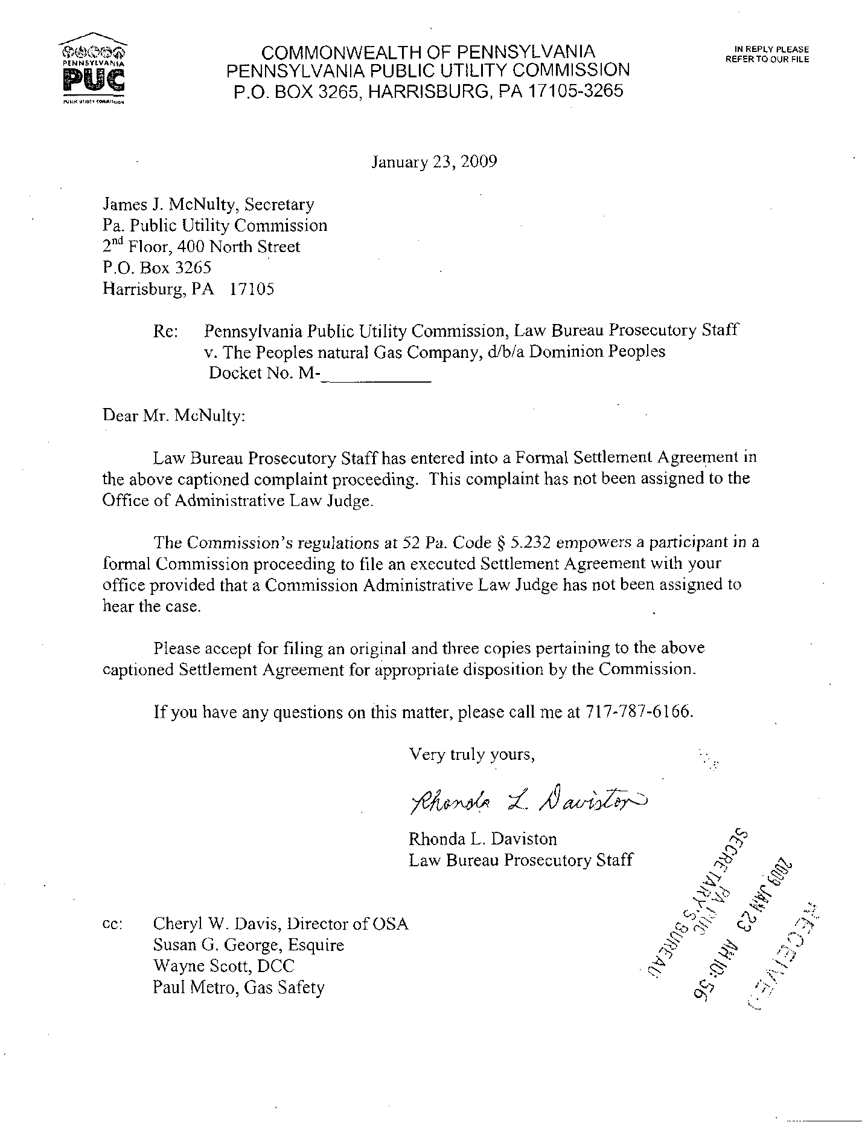
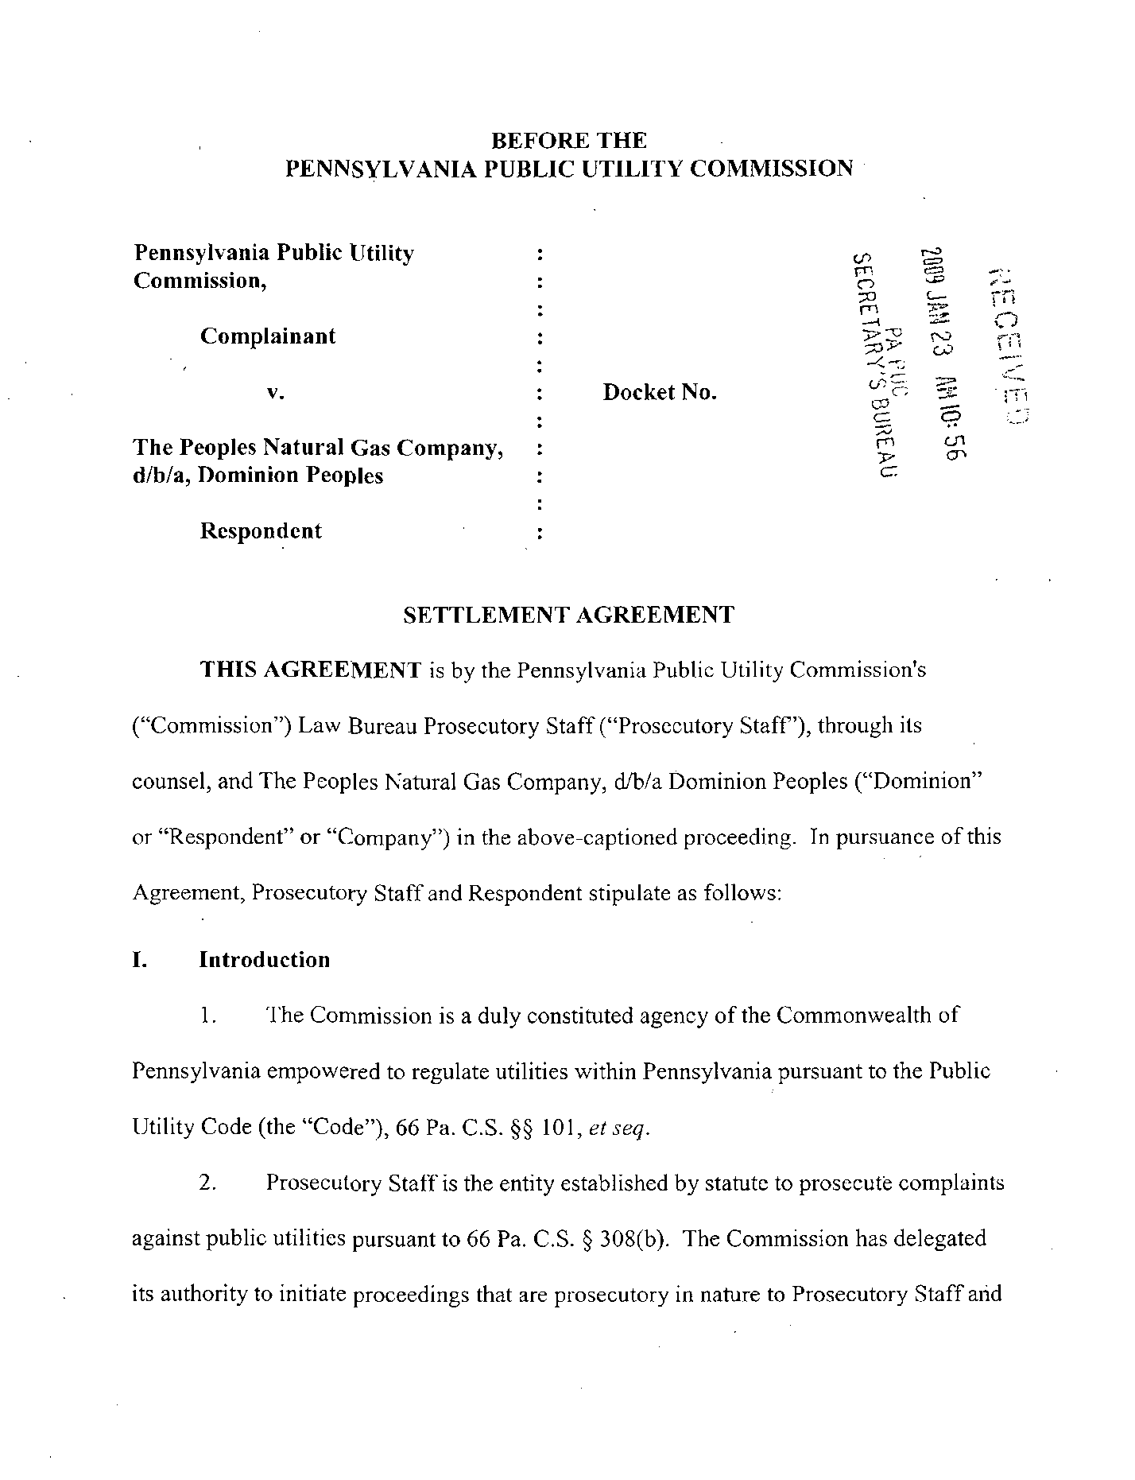
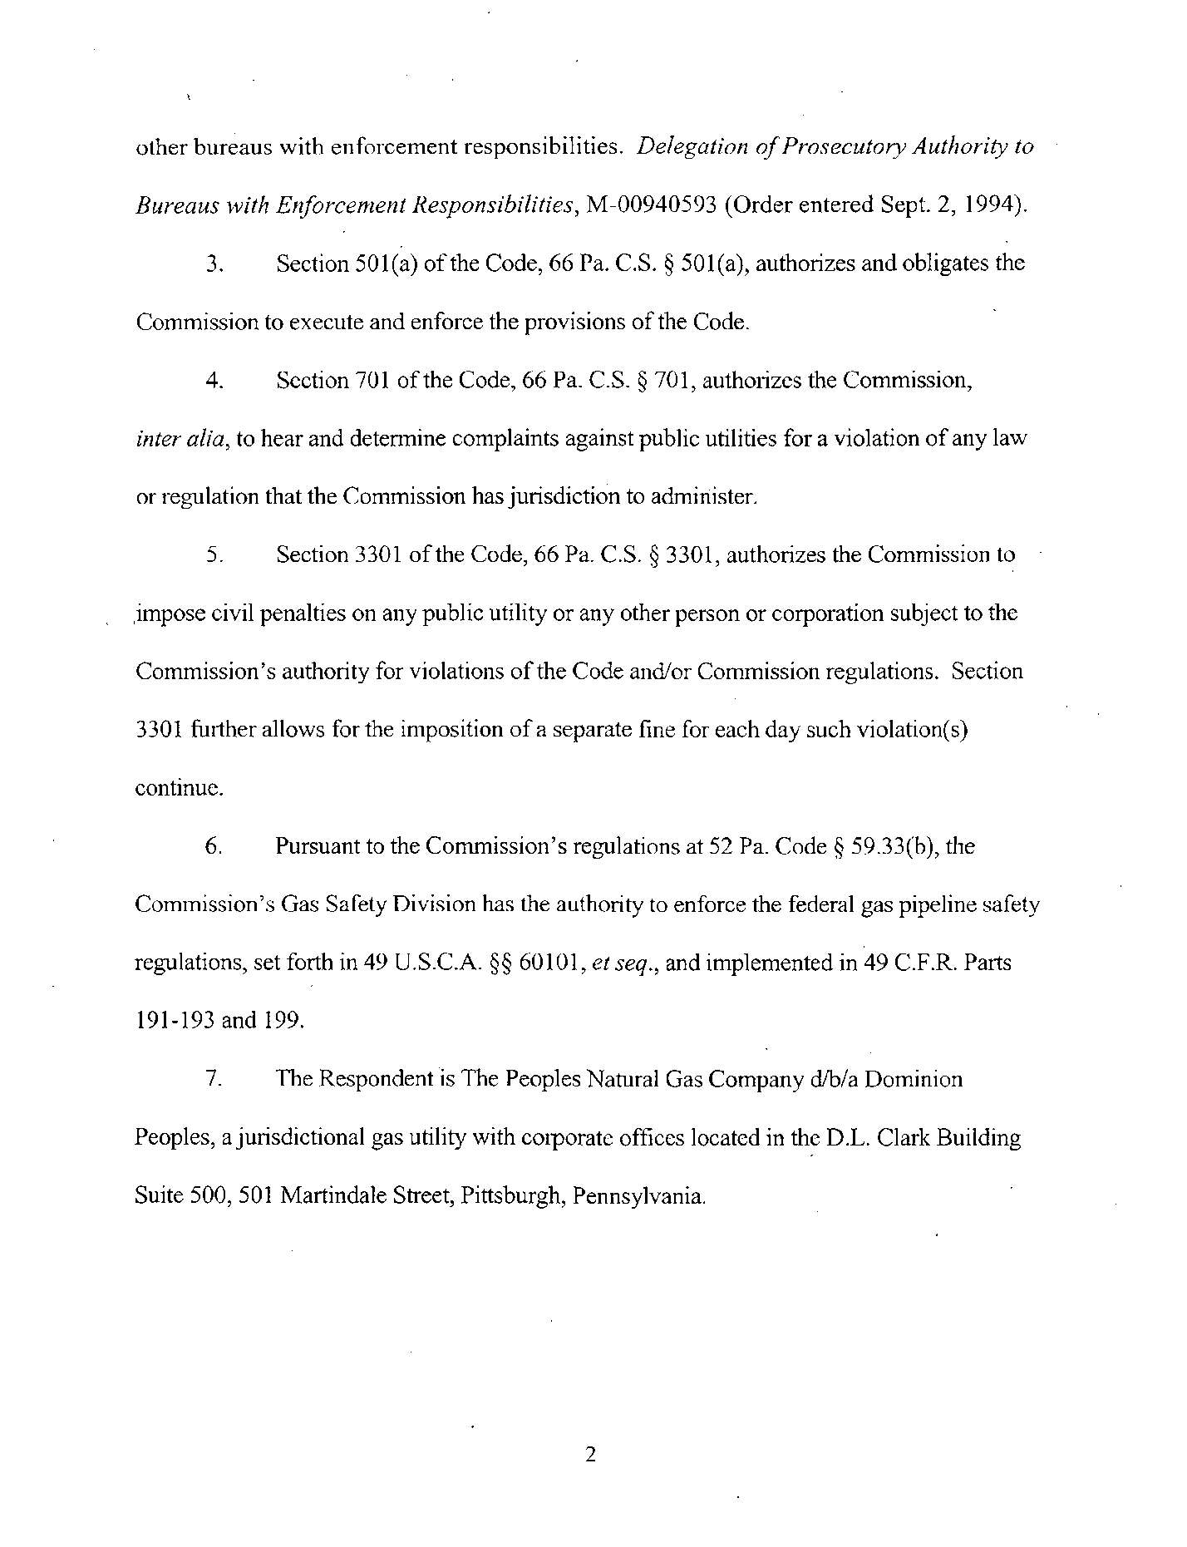
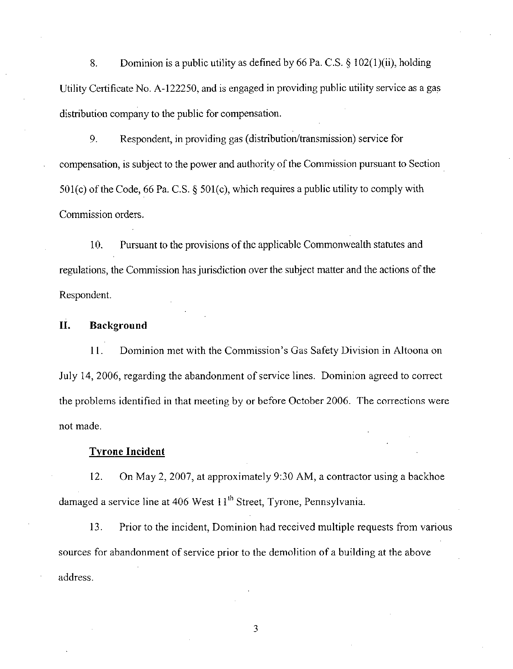
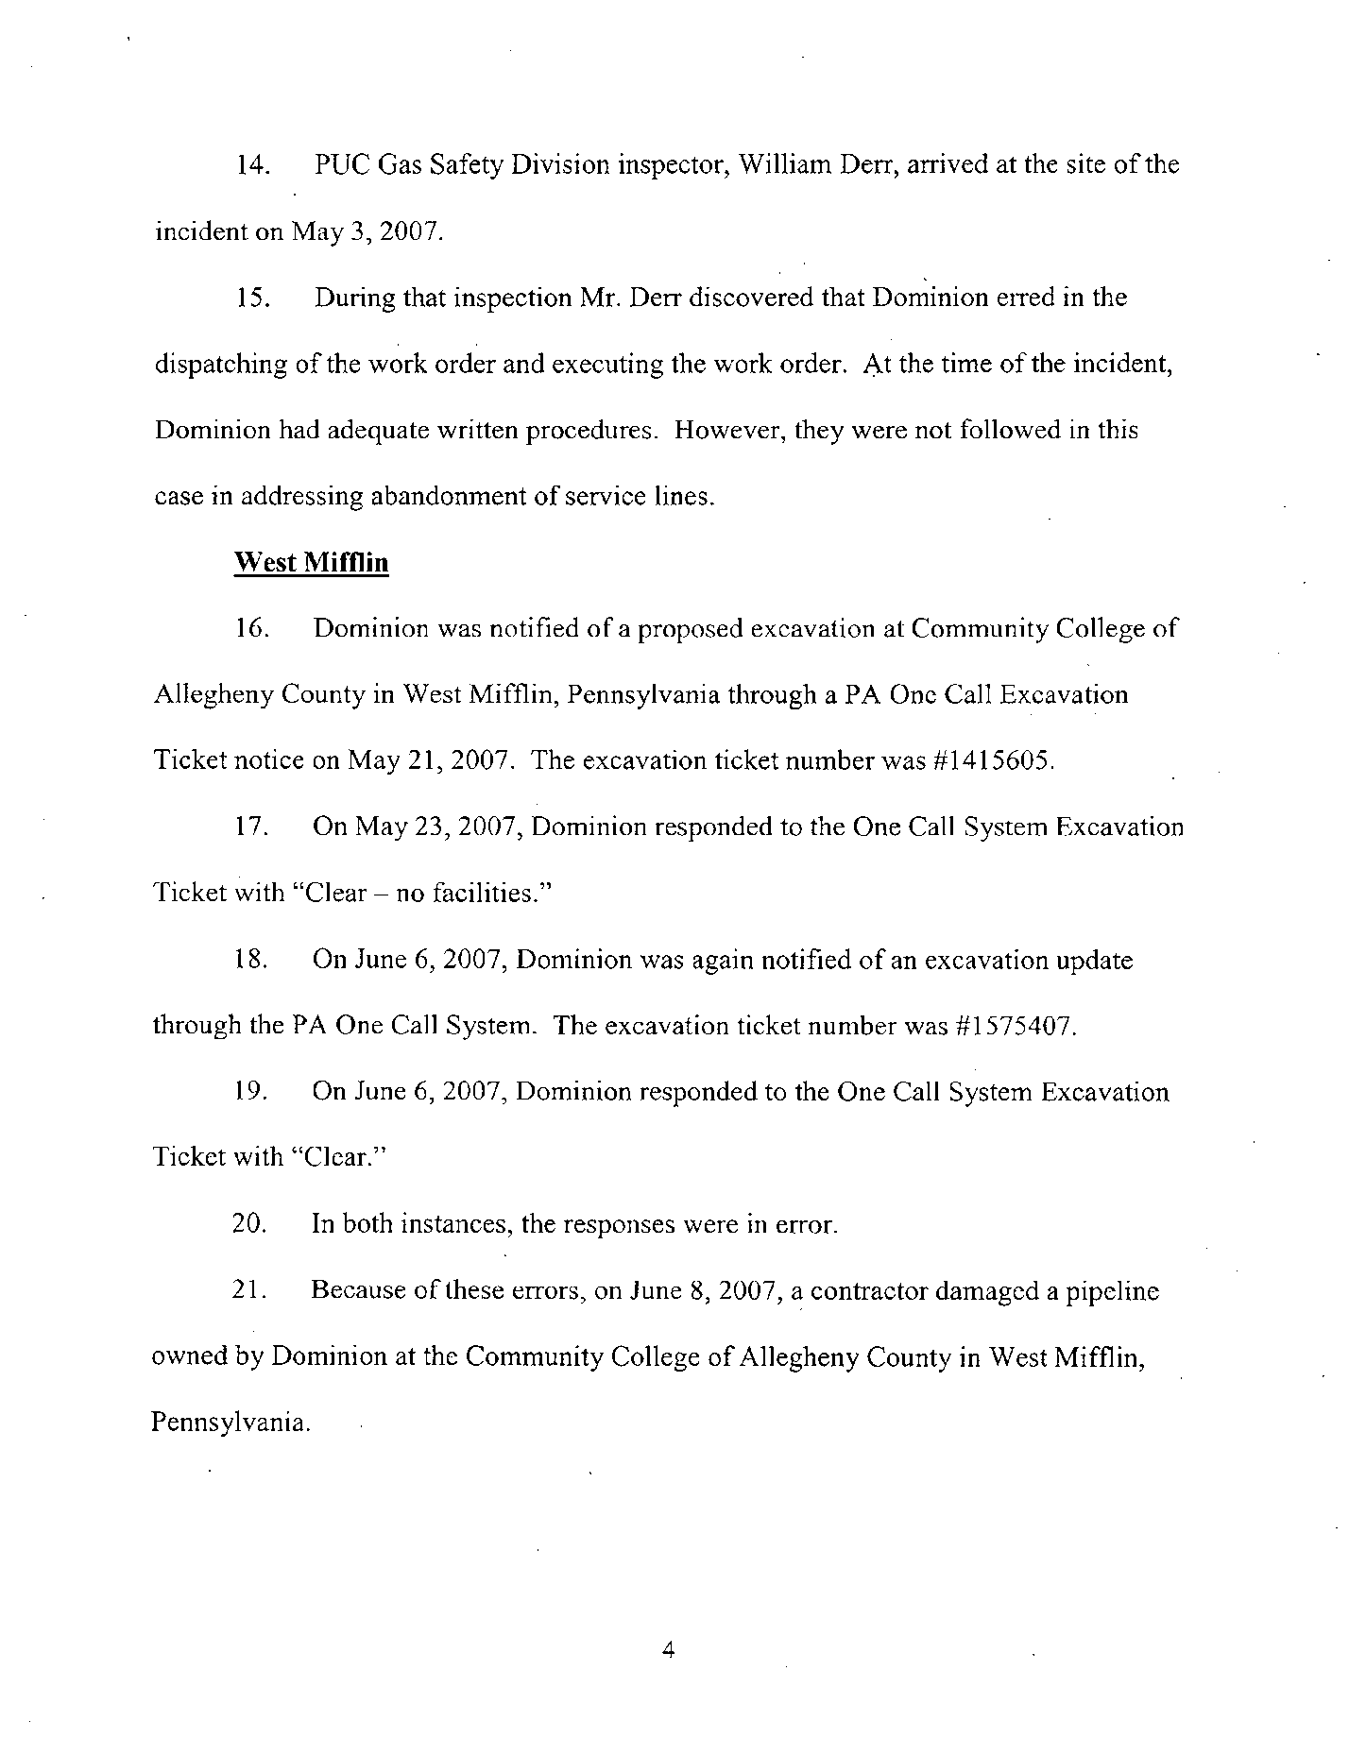
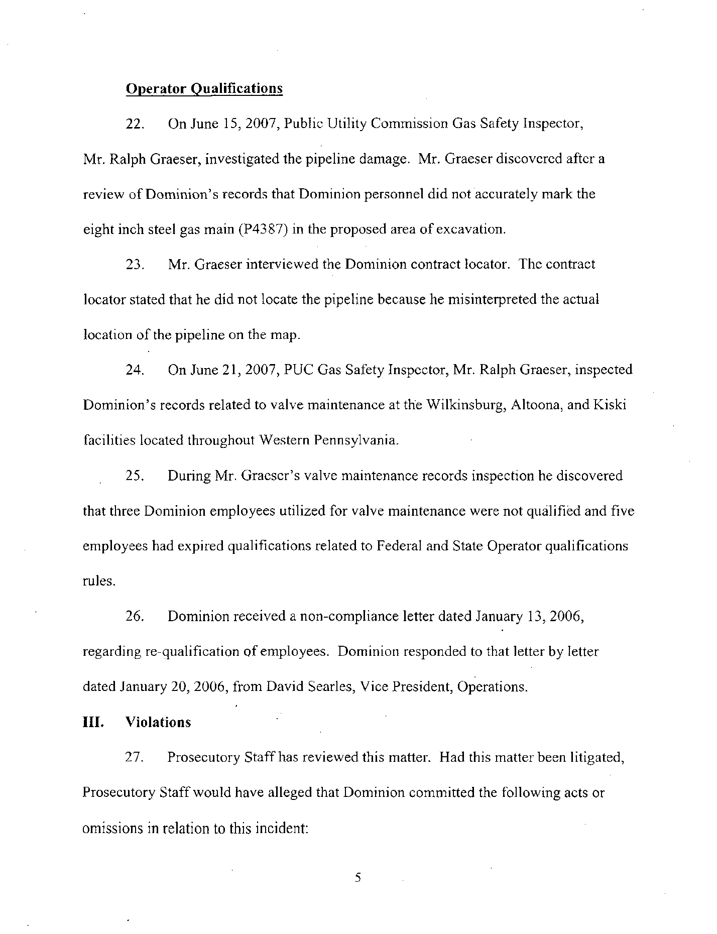
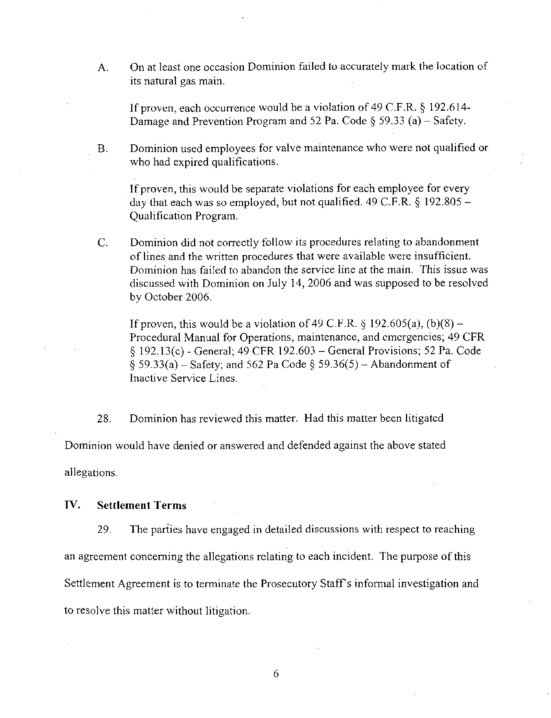
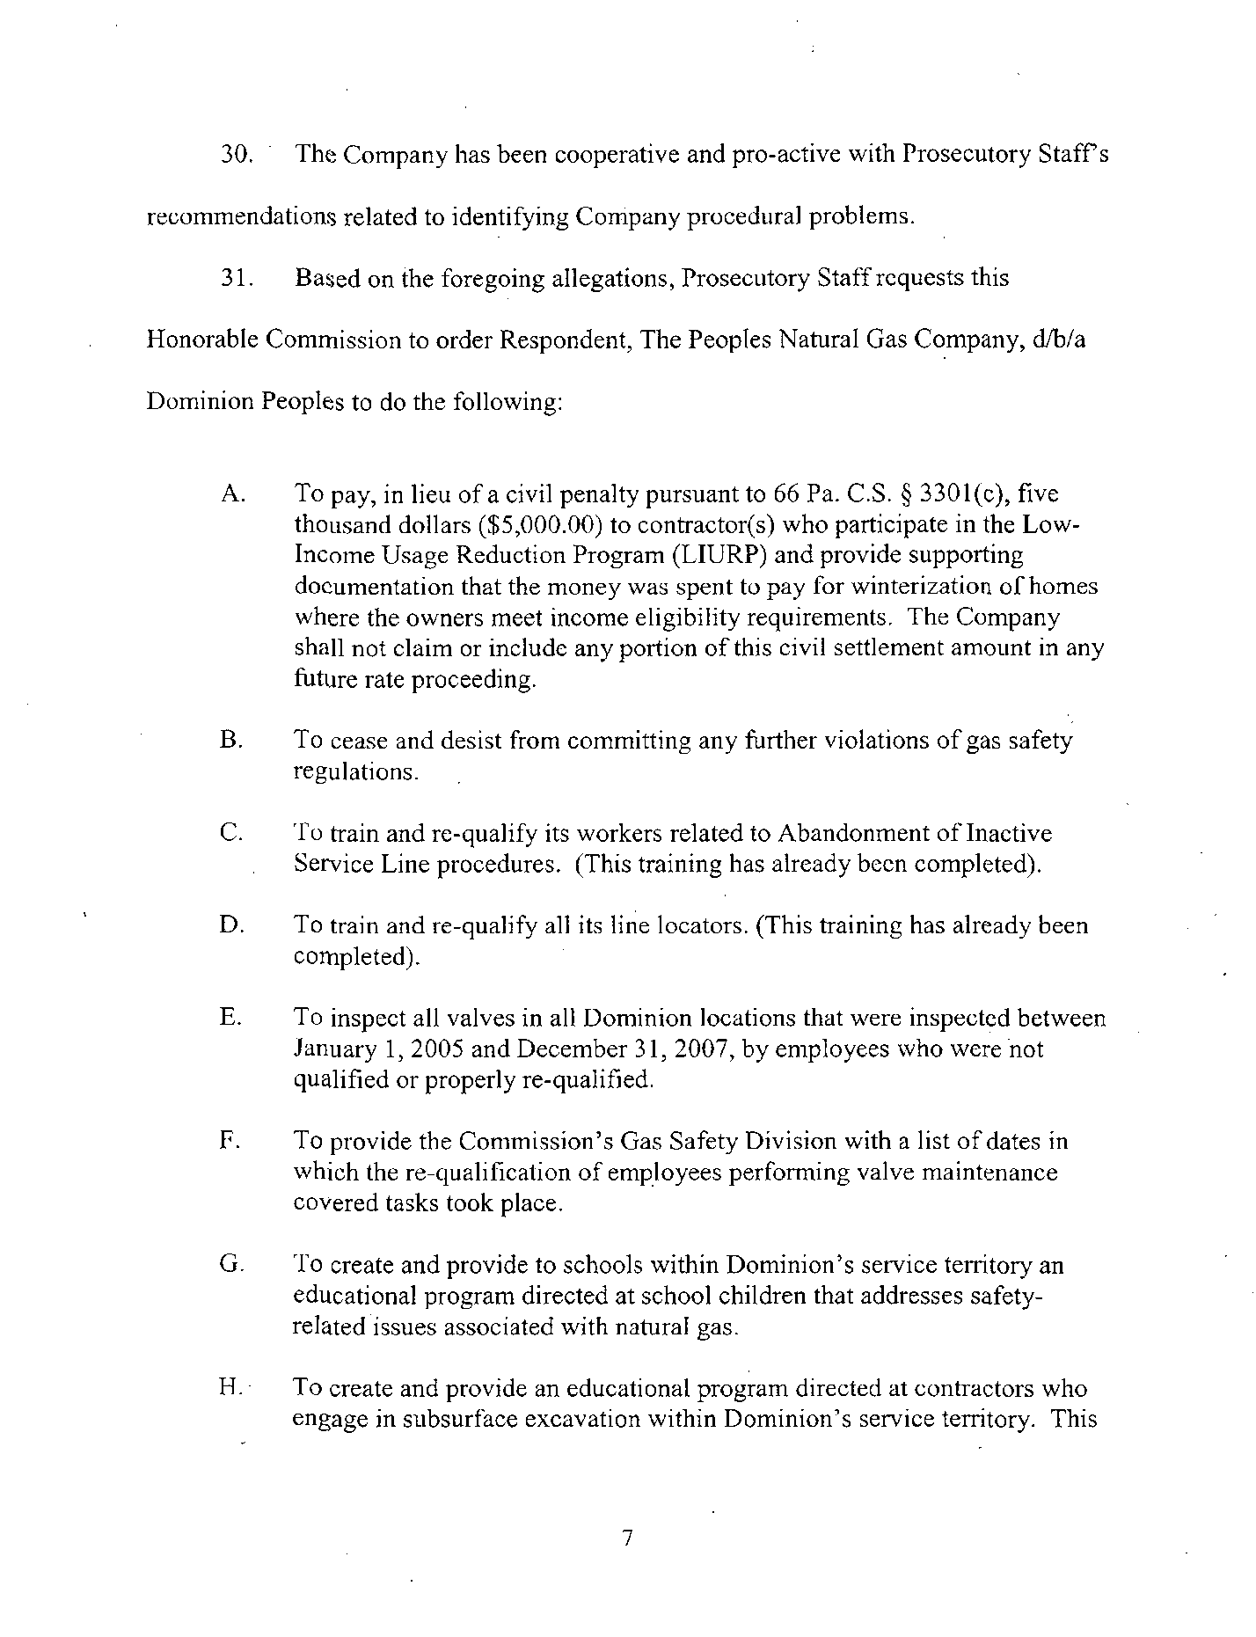
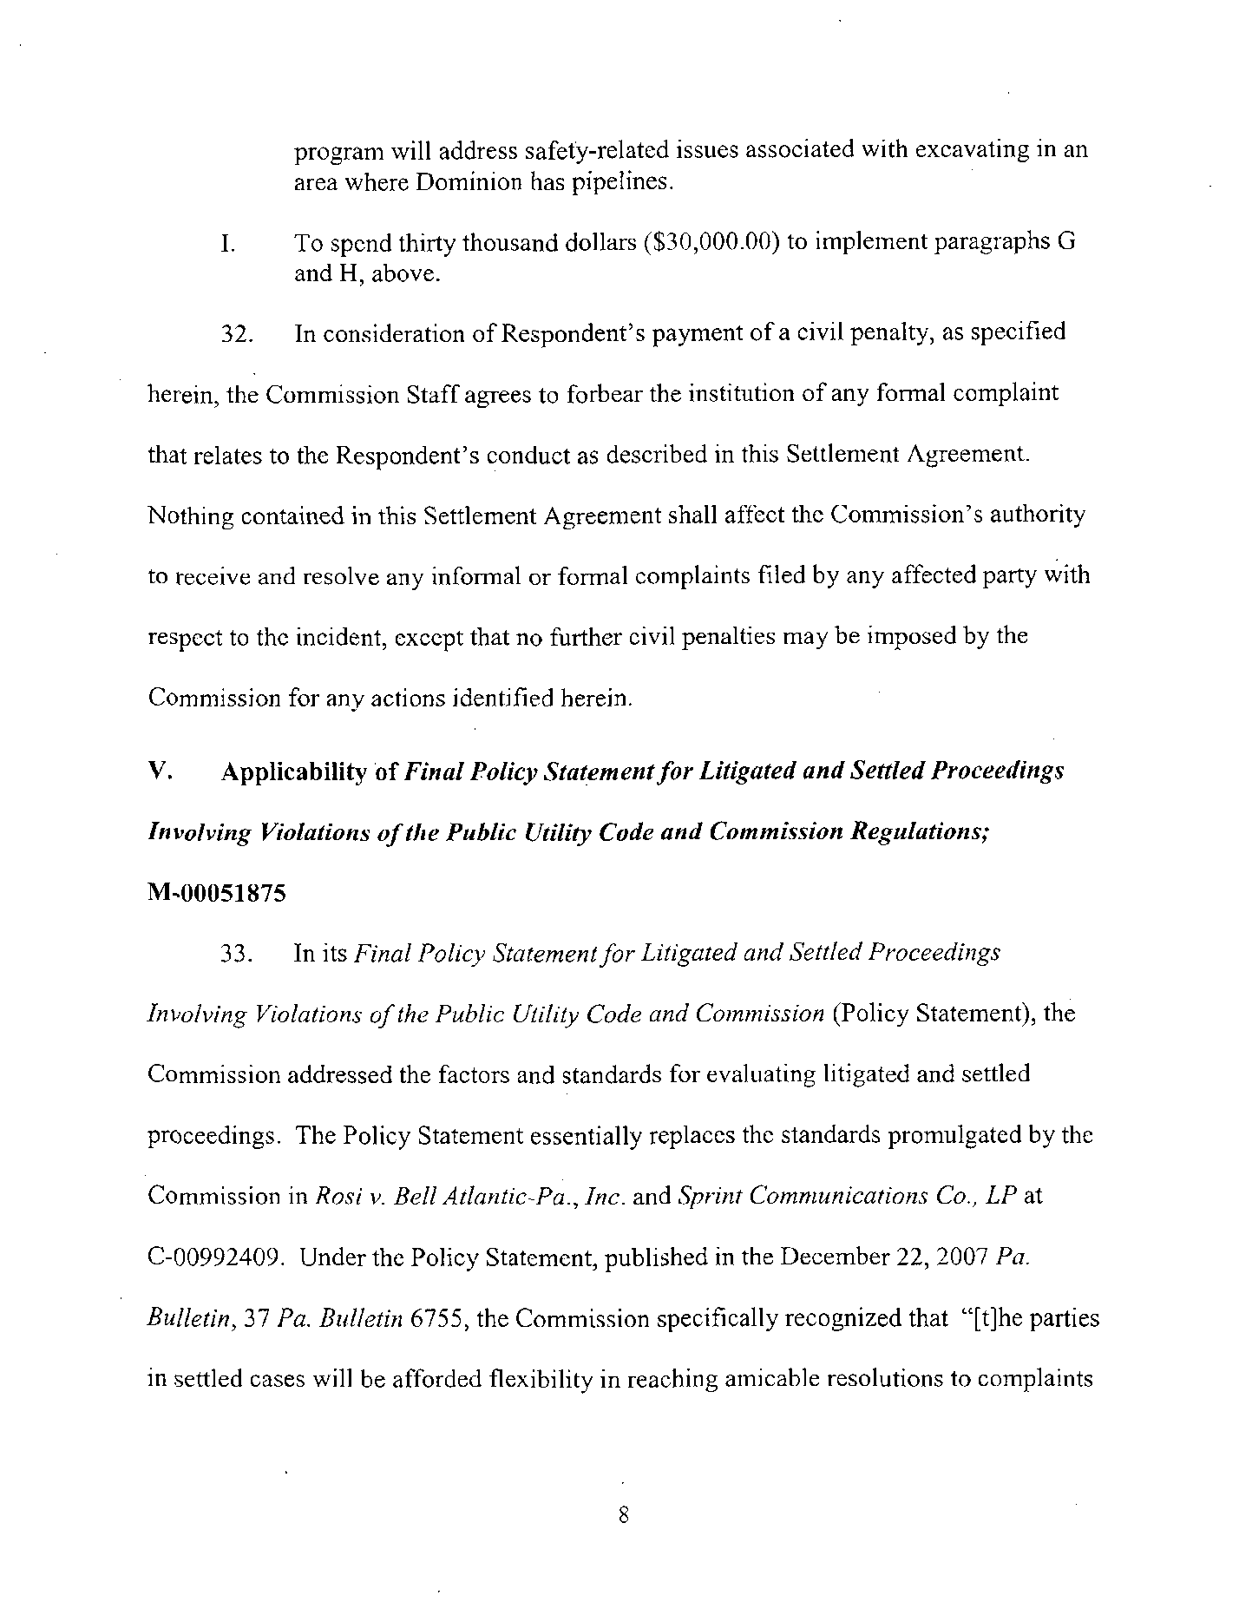
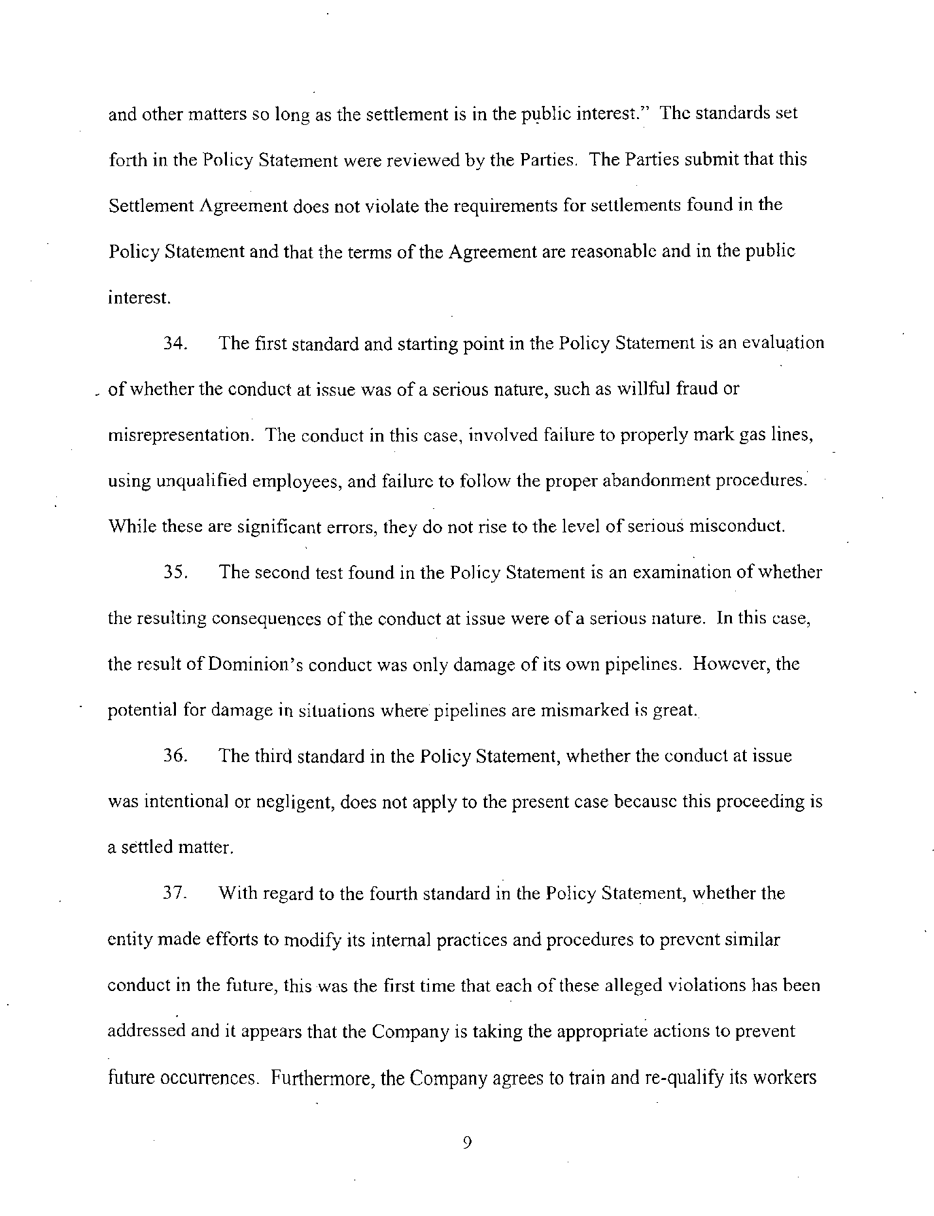
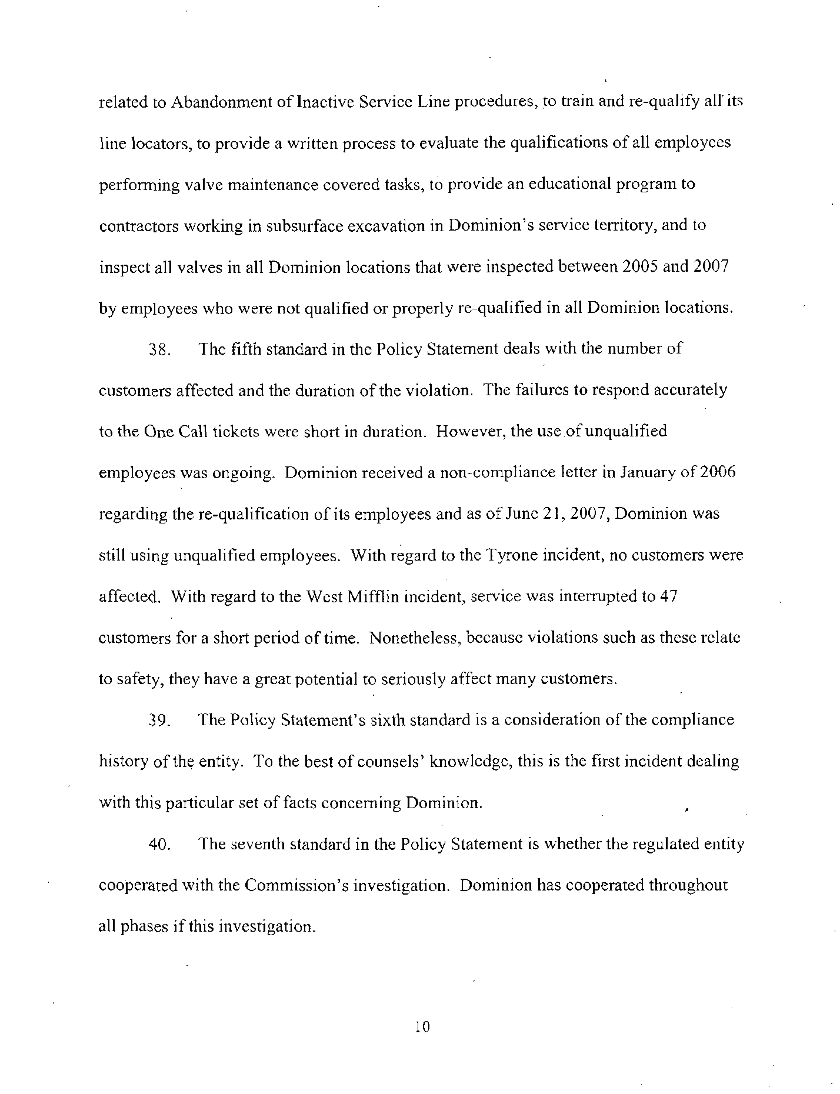
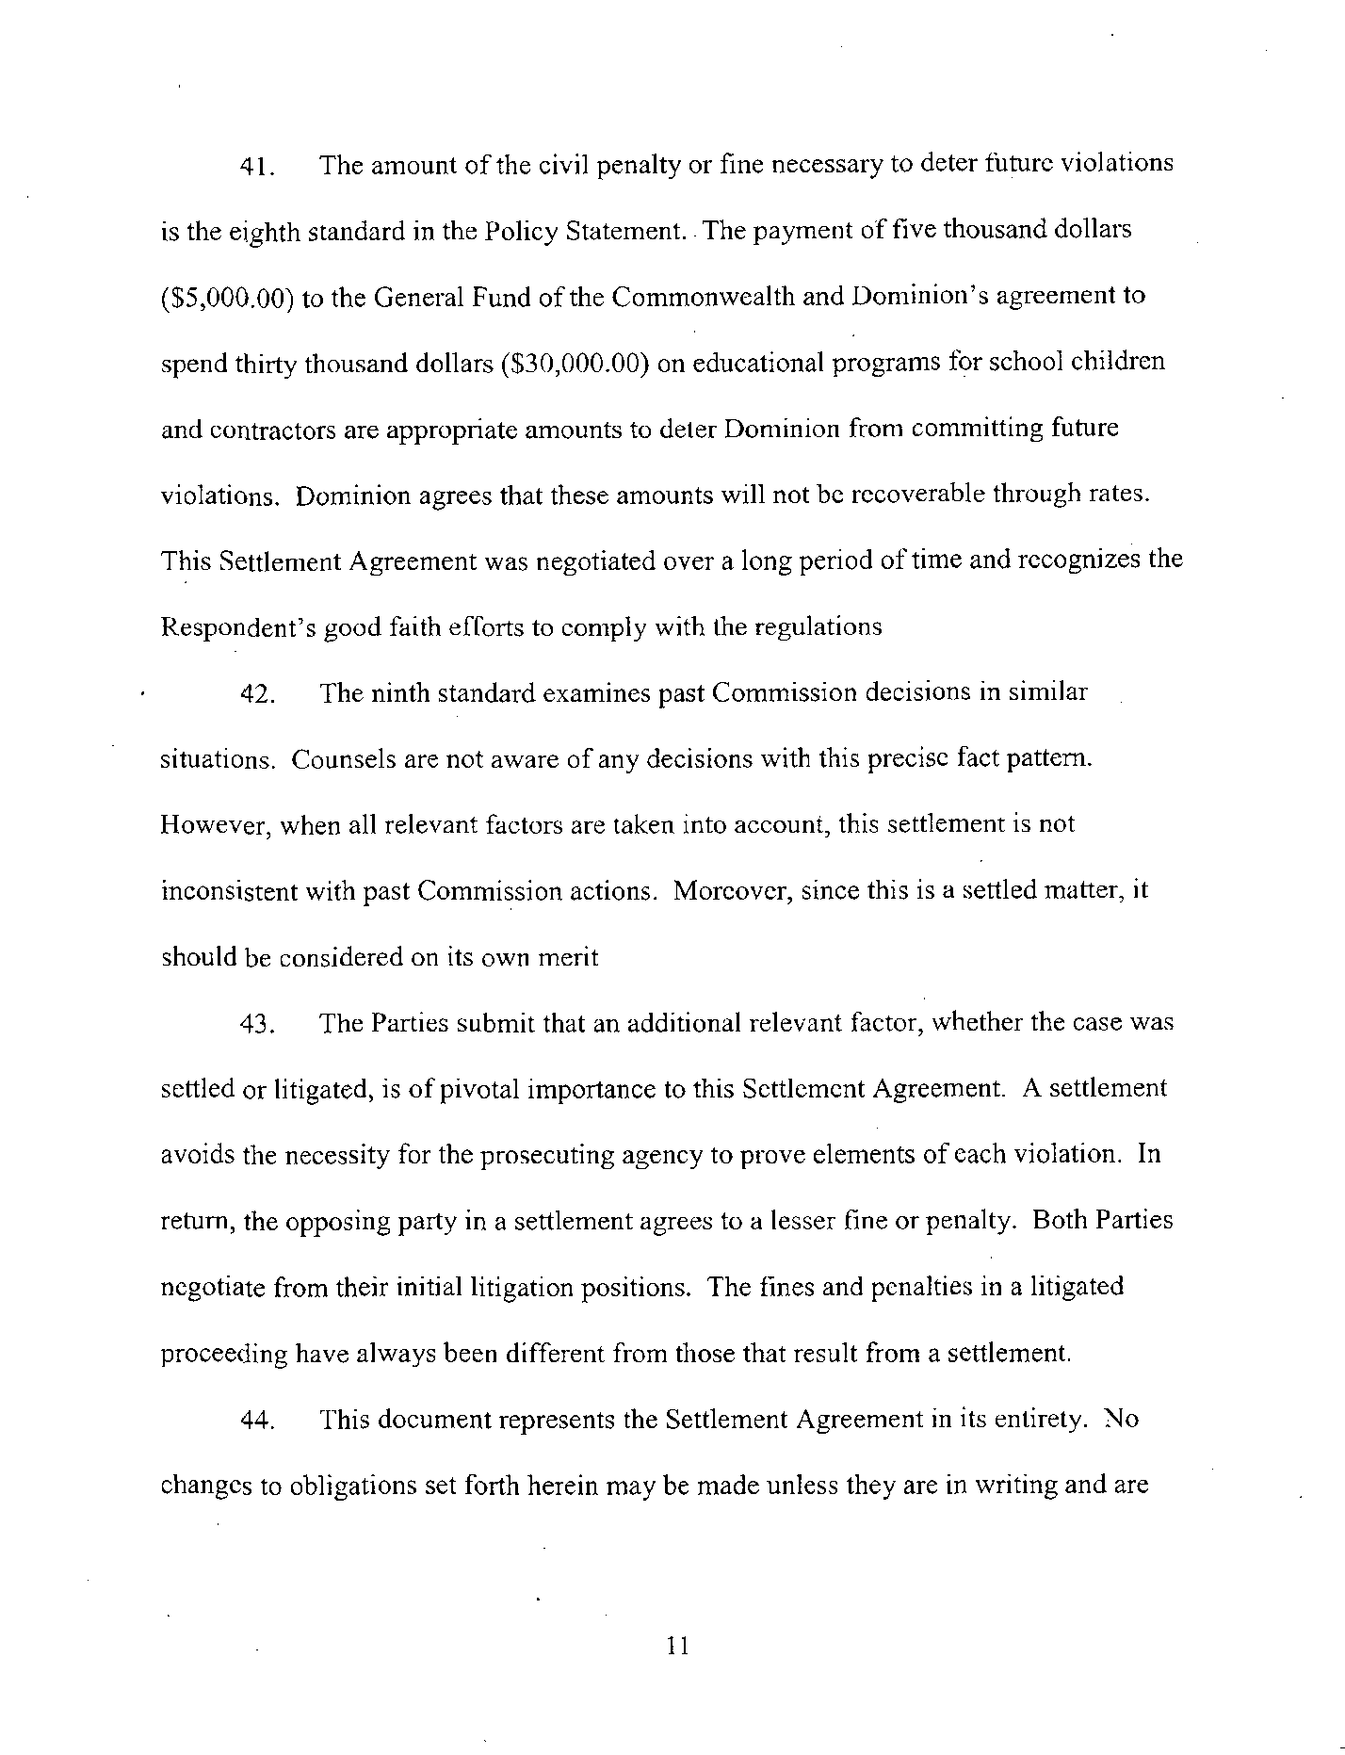
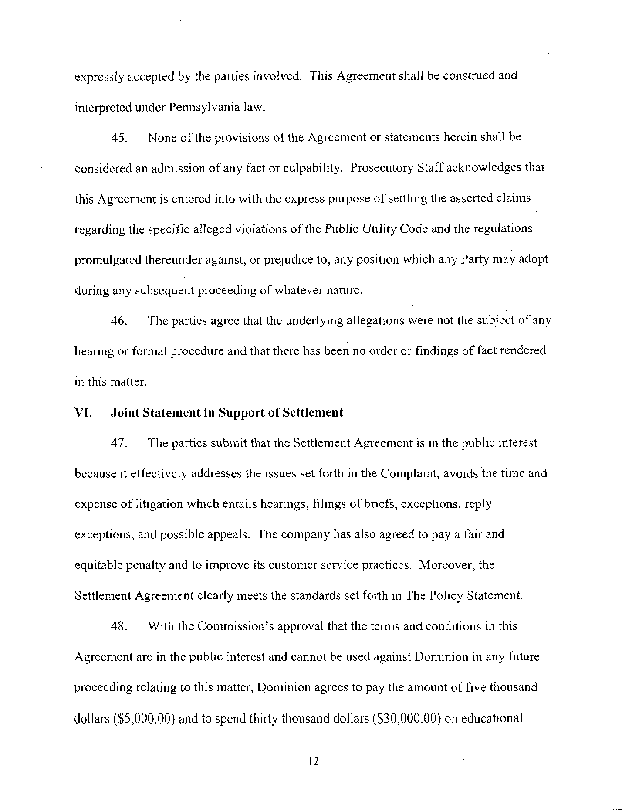
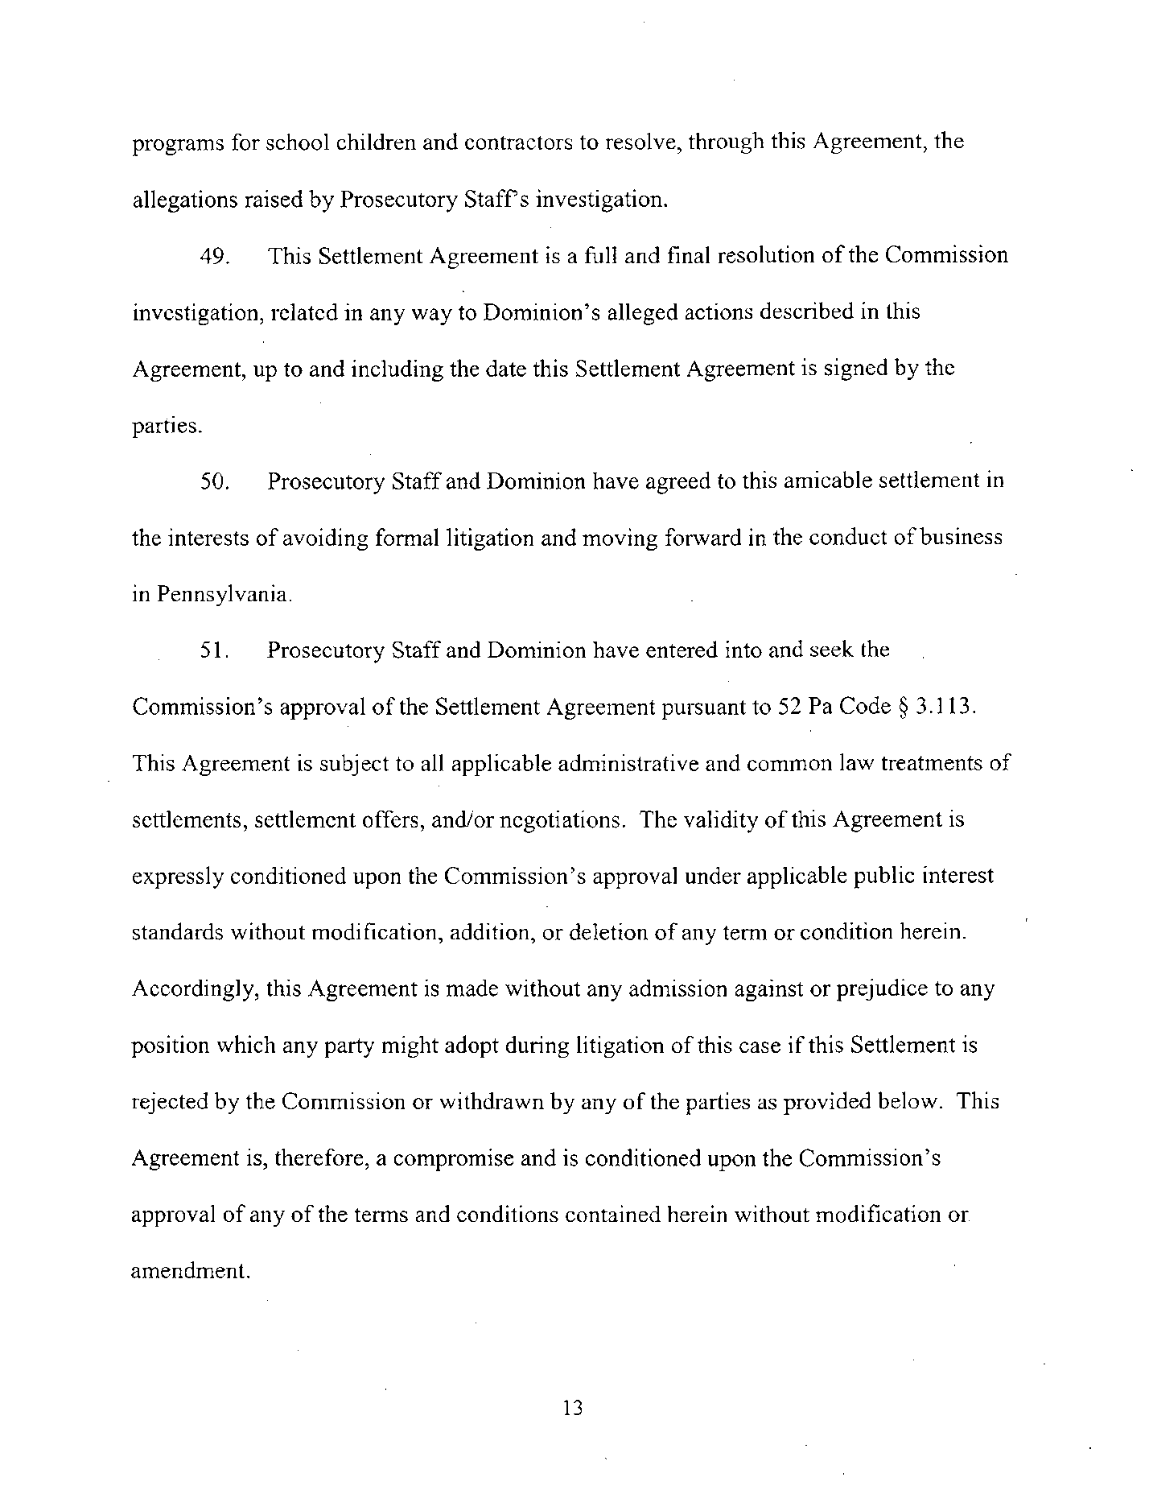
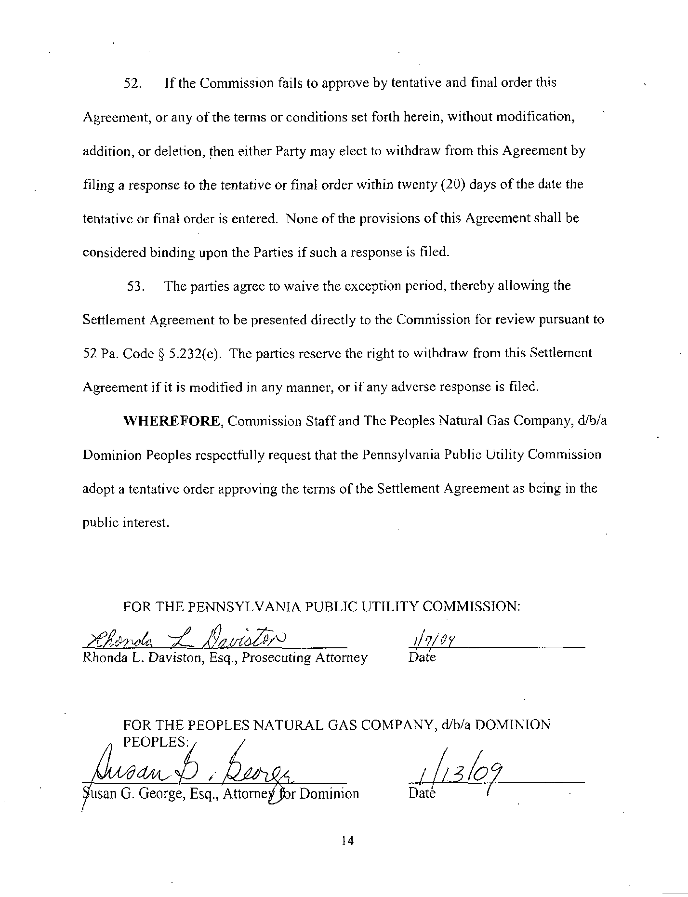

On April 24, 2009, the Parties filed a revised Settlement Agreement that clarified the point that the $5,000 civil penalty referenced in the Settlement Agreement is to be made to Low-Income Usage Reduction Program (LIURP) contractors while $30,000 is to be spent to create educational programs as described in the Settlement Agreement. On May 28, 2009, the Parties agreed to an amendment of Paragraph 31 A of the Settlement Agreement.
The language in the body of this Order is the language proposed in the Motion of the Vice Chairman on May 14, 2009, which was agreed to by the Parties on May 28, 2009. The original language of the Settlement reads: To pay, in lieu of a civil penalty pursuant to 66 Pa. C.S. § 3301(c), five thousand dollars ($5,000.00) to contractor(s) who participate in the Low-Income Usage Reduction Program (LIURP) and provide supporting documentation that the money was spent to pay for winterization of homes where the owners meet income eligibility requirements. The Company shall not claim or include any portion of this civil settlement amount in any future rate proceeding.

